**Bootcamp Project 5**

**Task 1:  
Migration of a Pipeline from Azure Data Factory to Synapse.**

* **Pipeline created to store all the five Azure Sql tables’ data in ADLS in csv format.**

1. **Creation of Meta Table**- It stores Schema name, Tables name and the folder name of all the five tables.  
   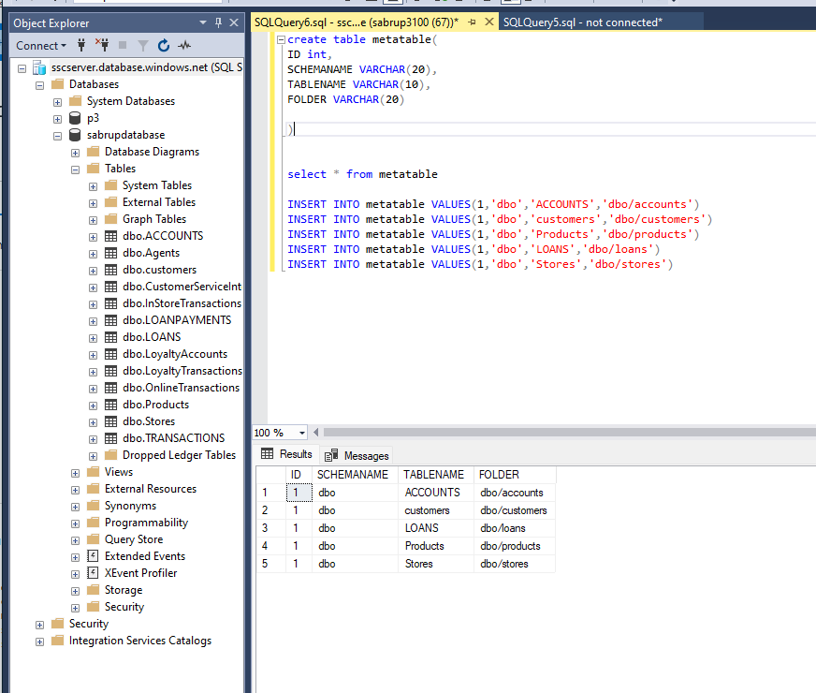
2. To migrate the data, I used lookup activity, ForEach and Copydata activities.  
   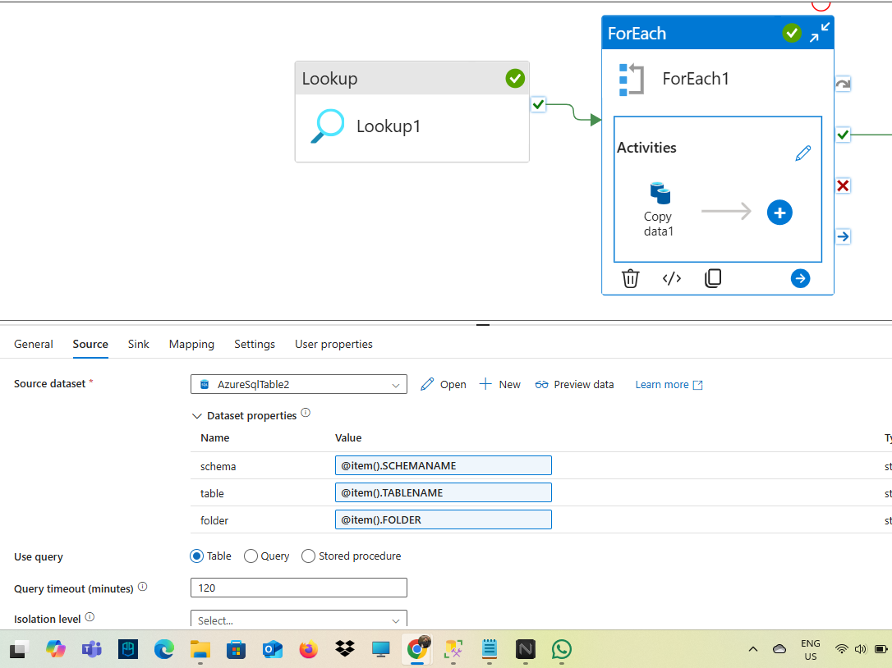
3. To store the clean data I used Dataflow with 5 sources.  
   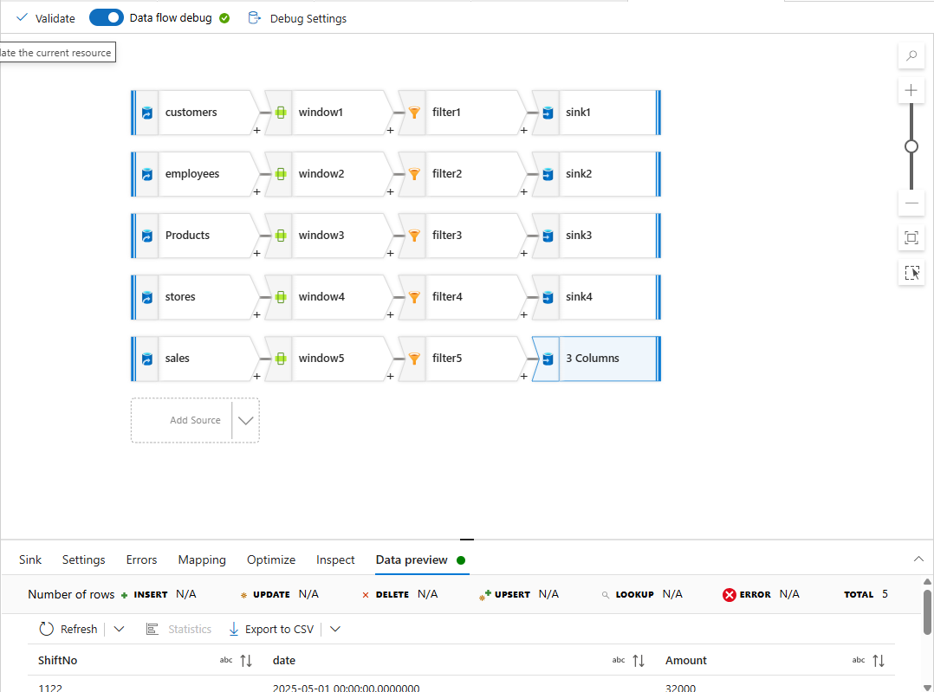  
   Here I used window and filter transformations to clean the data.

**Successfully Running Pipeline:**

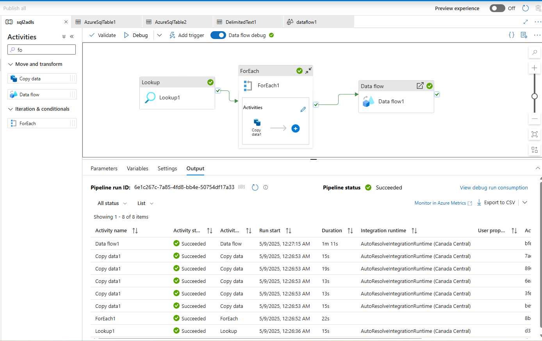  
  
Here dbo stores all the raw files and silver_folder stores clean files.  
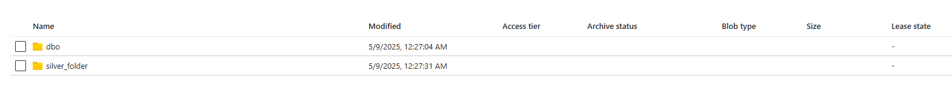

**To migrate the whole pipeline to Synapse, I clicked export template  
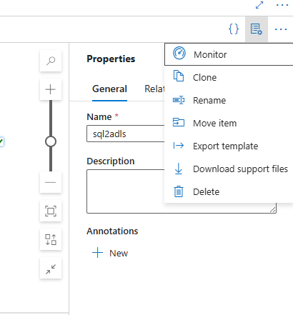**

**Then in Synapse I selected + icon -> Import from pipeline template.  
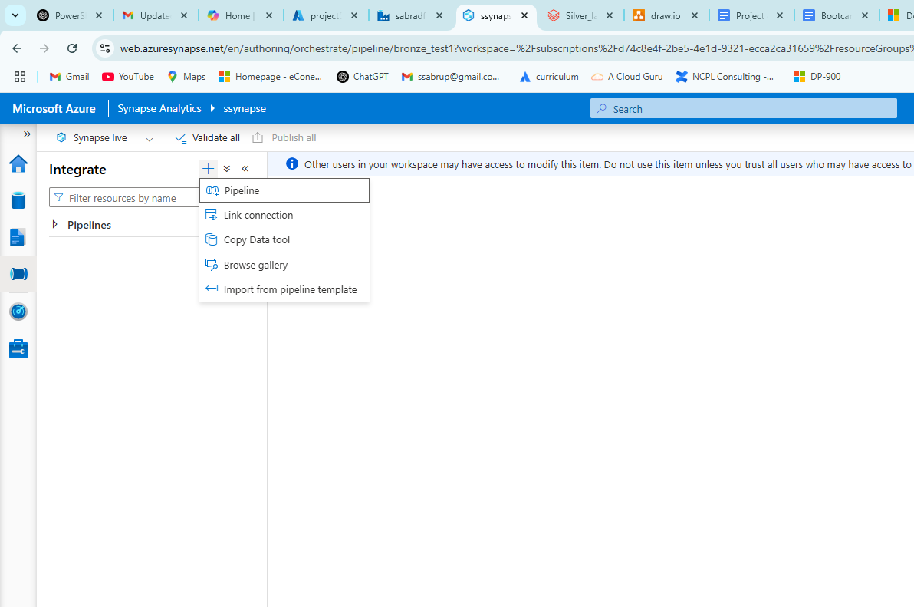  
  
Then Select the exported zip file from Azure Data Factory  
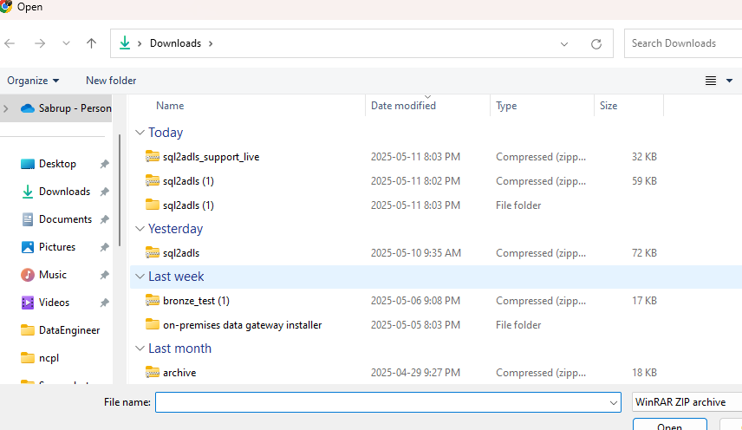**

**Create the necessary Linked Services:  
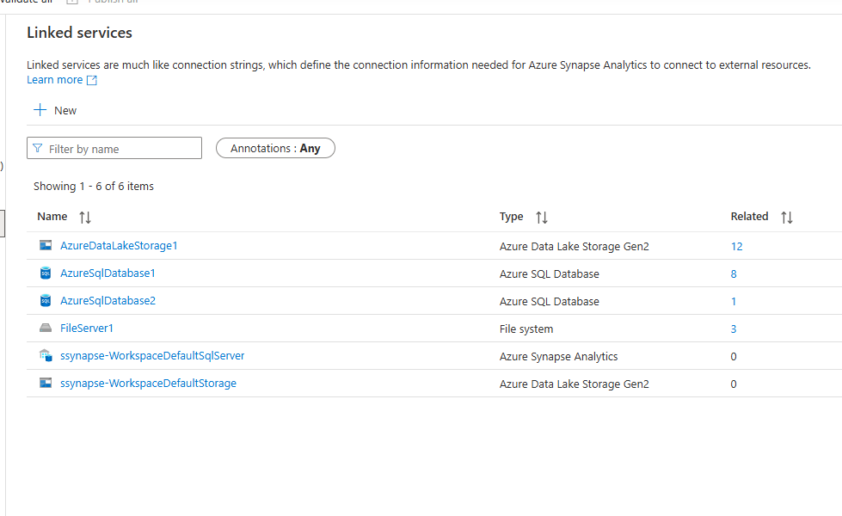**

**Then select the created Linked services  
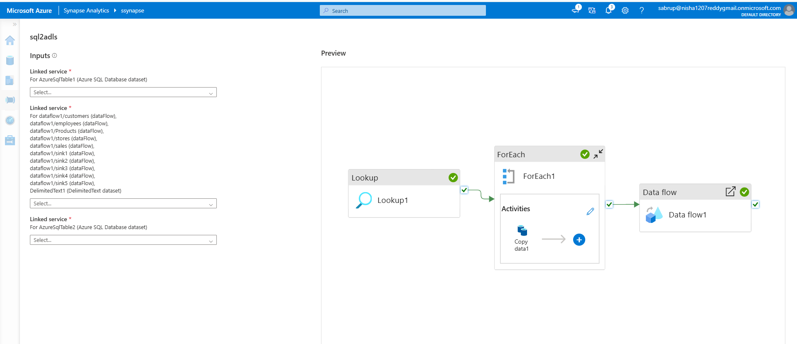**

**Then the pipeline is ready.**

**Task 2**

**Databricks migration to fabrics**

**Notebook 1**

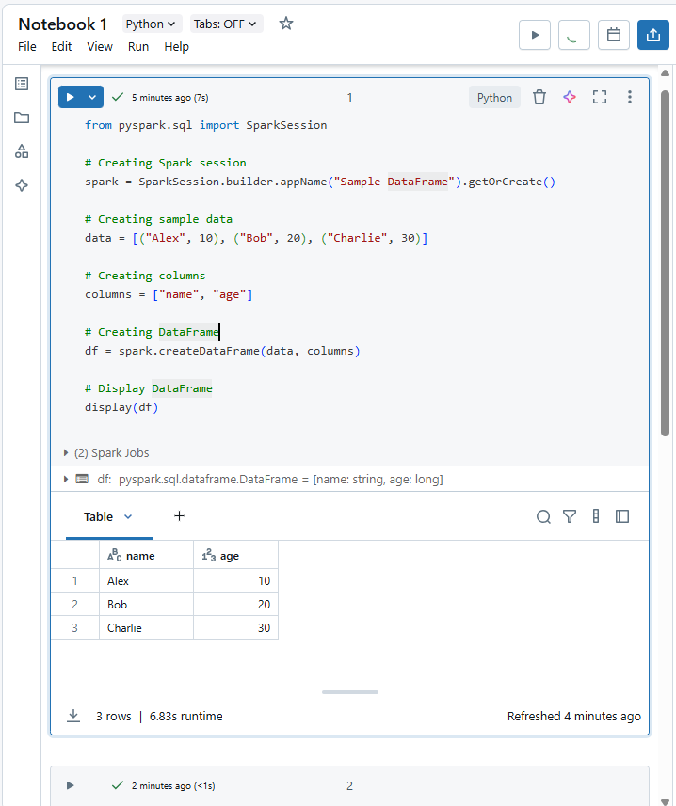

**Notebook 2**

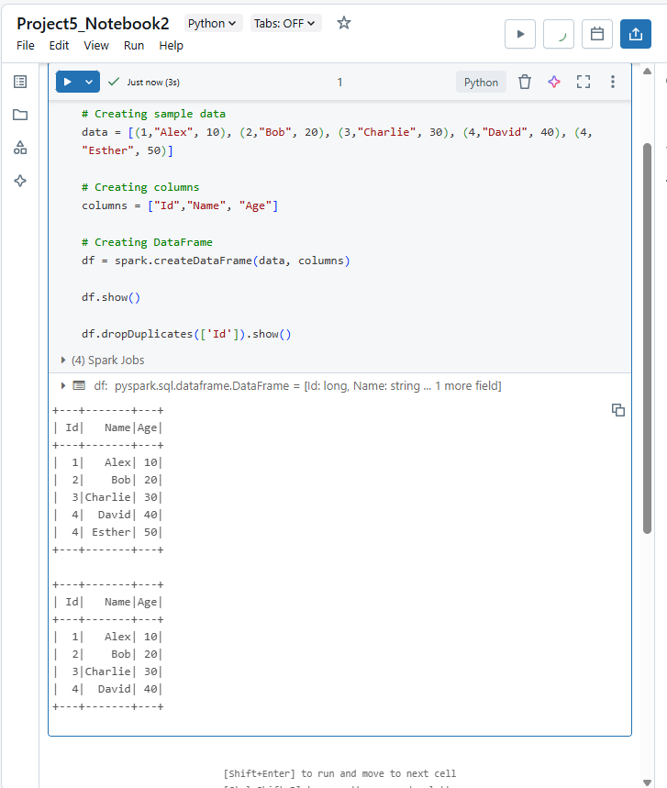

**Notebook 3  
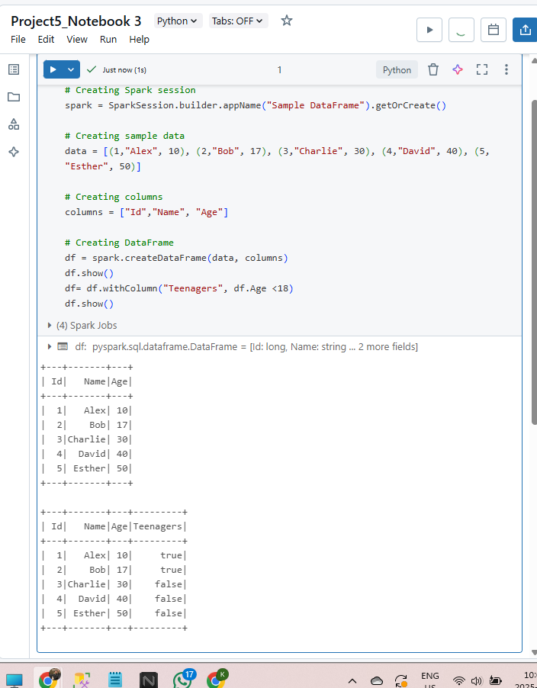**

**To migrate these notebooks, Export the Source files  
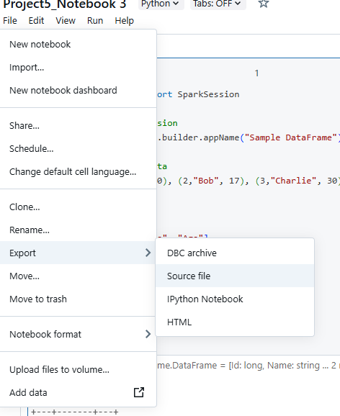**

**In Fabrics -> Workspace ->Import -> Notebook-> from this Computer**

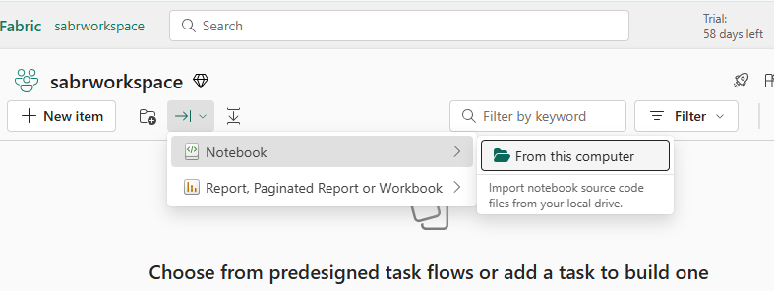

**Select the exported source files  
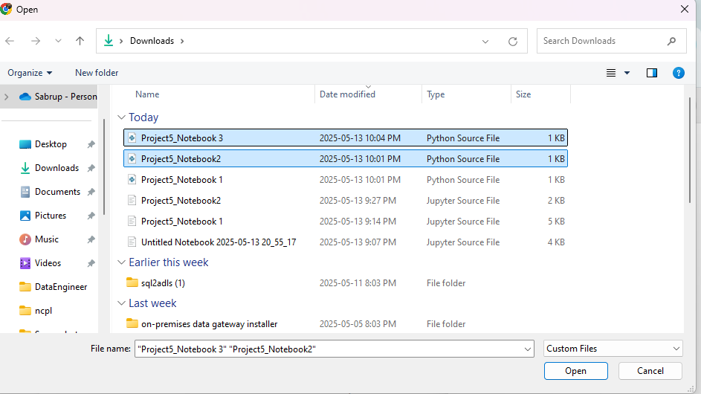**

**Here’s the 3 Migrated notebook  
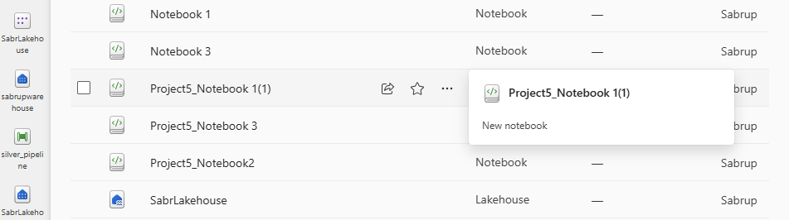**

**Here’s successfully running notebook in Fabrics  
